### Review of past research on digital Travel Pay submission challenges

#### 18F Mid-point review

As stated in the 18F mid-point review (slide 20-23):

* BTSSS contains superfluous screens, small text, confusing instructions, and un-intuitive interface design.
  + Design implication: Follow VA guidelines on font sizing and design patterns, especially those around form design. Look to PCI team’s work on information flows.
* Several Veterans expressed a desire for in-app support of some kind, whether through a chat box or a phone number on-screen.
  + Design implication: provide some way to seek support (Help section, hotline, etc)
* Information is poorly presented with very little hierarchy
  + Design implication: Follow clear headers, segments and hierarchy

As stated in 18F Mid-point review (slide 35):

* Many appointments don’t show up within BTSSS and have to be added manually, which Veterans struggle with.
  + Design implications: provide users a clear, easy to use way to add claims. Increase the prominence of this CTA.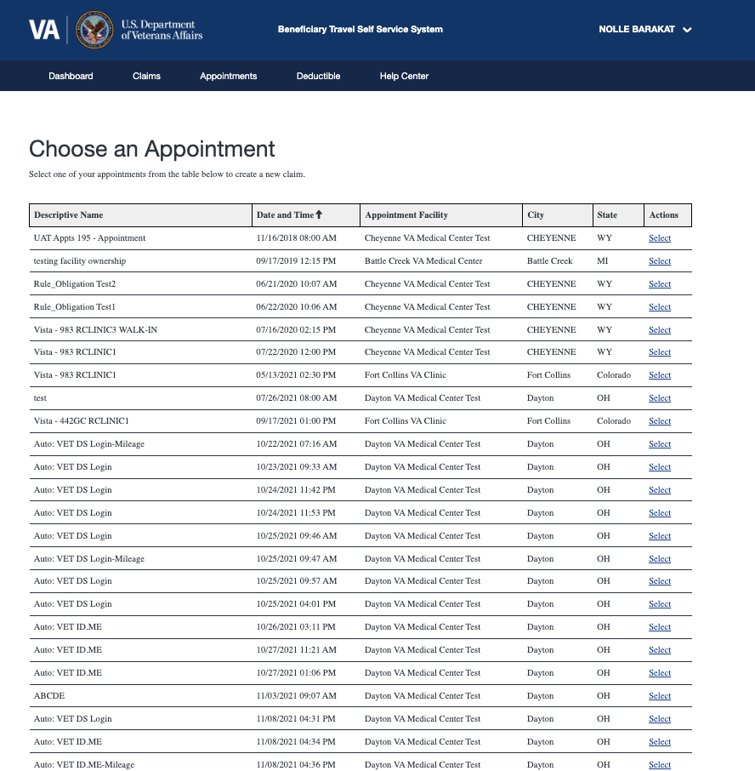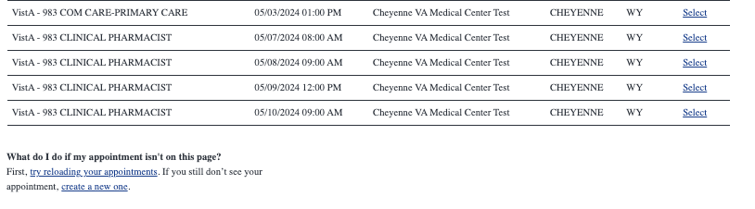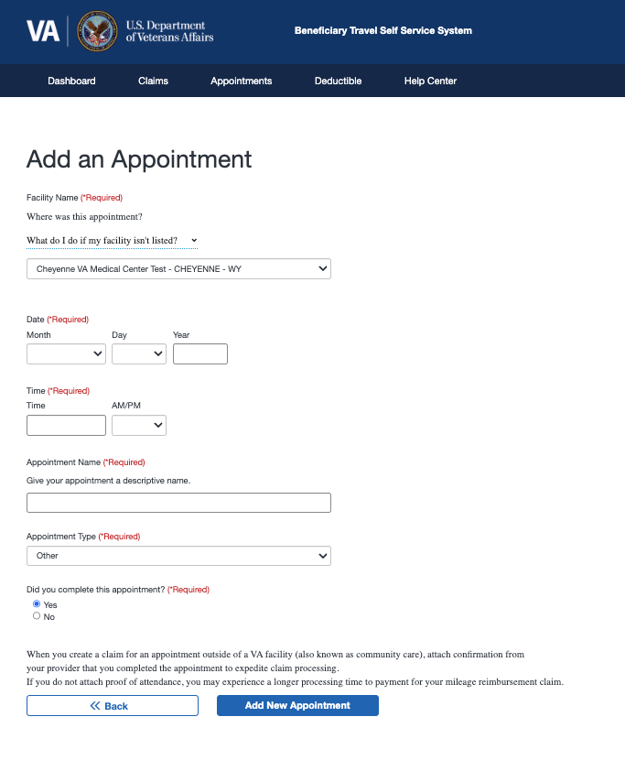
* It’s unclear what your claims status is once submitted.
  + Design implication: Provide users with a way to become aware of or directed to the Status page

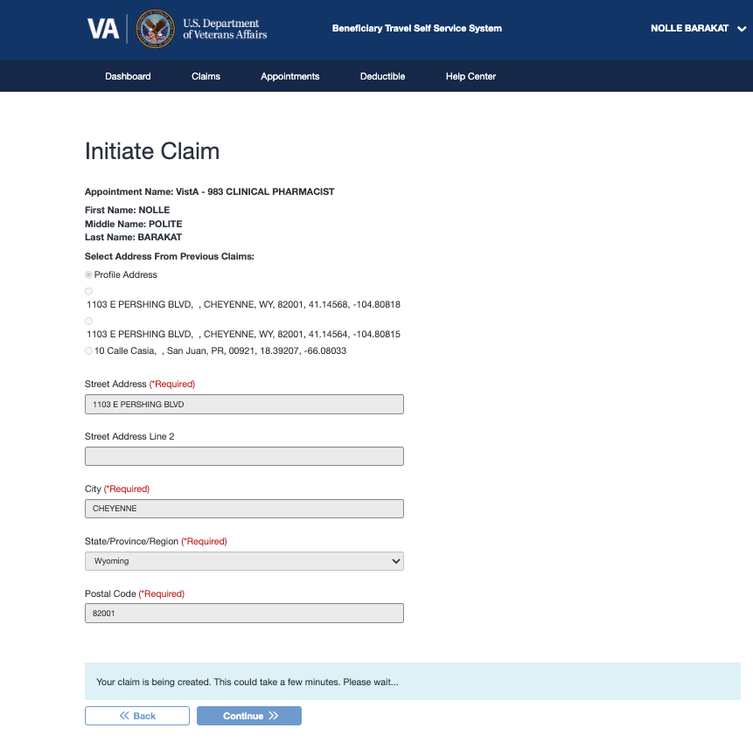

#### PCI Research

Refer to study: [Modernized Check-in Experience, Travel Reimbursement 10/2022](https://github.com/department-of-veterans-affairs/va.gov-team/blob/master/products/health-care/checkin/research/veteran-facing/travel-reimbursement-mvp-remote-test/research-findings.md)

**Problem** from 18F research: BTSSS contains superfluous screens, small text, confusing instructions, and un-intuitive interface design.



**Solution from PCI:** Because the submission starts as attached to an appointment in a known location (because they are checking in) the PCI flow is able to utilize a simple yes/no confirm process leveraging known information.

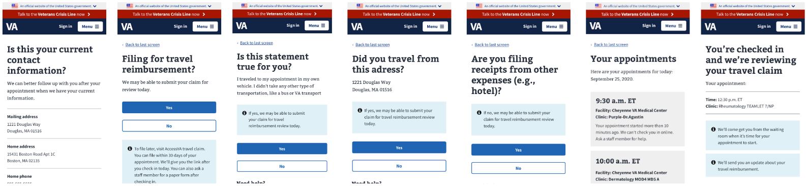

Problem identified from 18F: Users are unclear what comes after submission. Solution from PCI: tell users that they will be sent an update about their travel reimbursement.